Photos to Phylogenies: A Scavenger Hunt to Explore the Tree of Life
By Dr. Caitlin Conn, Berry College

Background and objectives

Phylogenies are tree-like structures that illustrate evolutionary relationships. From the history of life on Earth to the evolution of a single gene in one intra-host viral population, phylogenies represent important evolutionary stories. Therefore, it is important for students of biology to know how to read, analyze, and even create them.

In this activity, you will receive an introduction to phylogenetics in the form of a lecture and simple problem-solving activities. You will then work outdoors in a small group to complete a photographic scavenger hunt for members of an assigned taxonomic group. After collecting your photos, you will return to the classroom, where you will identify the organisms in your photographs and build phylogenetic trees to represent their relationships. By the end of this activity, you should be able to

- Explain the evolutionary relationships indicated by a phylogenetic tree
- Explore a local outdoor environment and discover local biodiversity
- Use iNaturalist to identify organisms from photographs
- Build a phylogeny based on easily observable characteristics
- Add or remove taxa from a phylogeny while maintaining the correct branching pattern
- Employ the principle of parsimony to map character state changes onto a phylogeny

Student worksheet

Introductory activities (15% of total grade)

- Your phylogenetic tree is on the next page. On it, draw arrows and/or other labels to identify the following:

- Most recent common ancestor of great white shark and manta ray
- Most recent common ancestor of goldfish and hagfish
- Outgroup species
- A monophyletic clade
- A paraphyletic clade
- A polyphyletic clade

Does this tree indicate that manta rays, great white sharks, blue gills, and goldfish evolved from hagfish? In other words, are hagfish an ancestor of the other four species in the tree? Why or why not?

Original tree: Answer (refer to this tree):
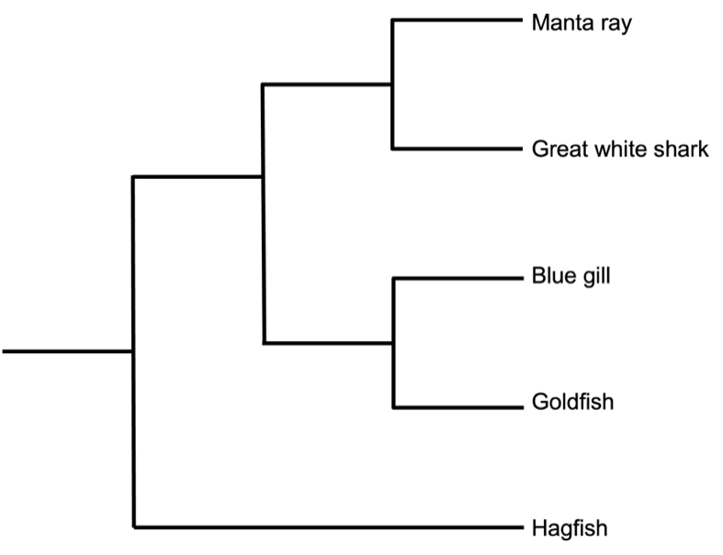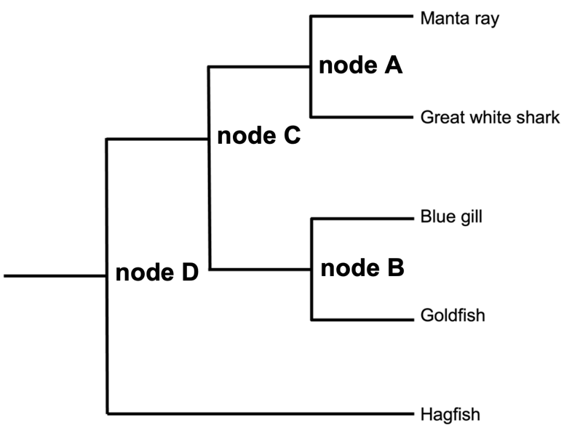
In the tree above, labels appear directly to the right of the nodes to which they refer. The most recent common ancestor (MRCA) of manta ray and great white shark is node A. The MRCA of goldfish and hagfish is node D. Hagfish is the outgroup. Several answers are possible for mono-, para-, and polyphyletic clades; one monophyletic clade is manta ray, great white shark, and node A. One paraphyletic clade is manta ray, great white shark, node A, blue gill, node B, and node C (goldfish is excluded to make this paraphyletic). One polyphyletic clade is the non-cartilaginous fish (blue gill, goldfish, and hagfish).

- Refer to the following tree. In the blank space that follows, redraw the tree
- with Sumatran tiger at the top of the tree (in the highest vertical position)
- with tiger swallowtail at the top of the tree
- with gray squirrel omitted
- with tiger swallowtail omitted (who’s the outgroup now?)

Be sure to preserve correct branching patterns in your four redrawn versions of the tree.

Original tree:

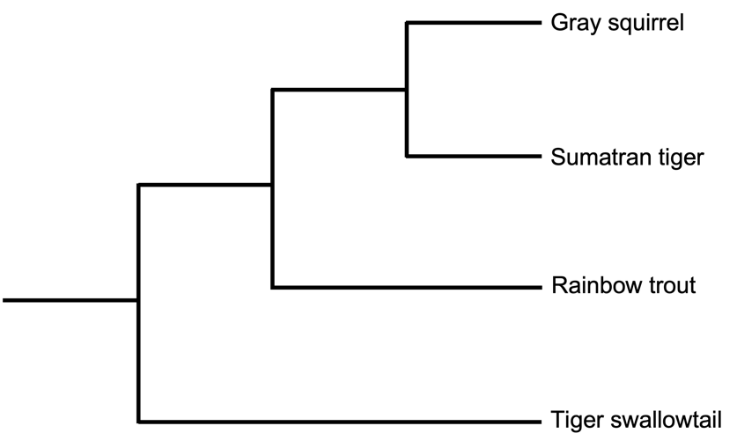

Answers:
The following trees all preserve the same branching pattern as the original tree.
Tree redrawn with Sumatran tiger at the top:
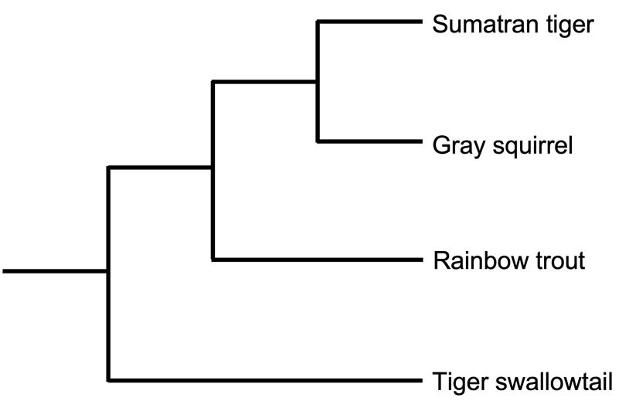
Tree redrawn with tiger swallowtail at the top:
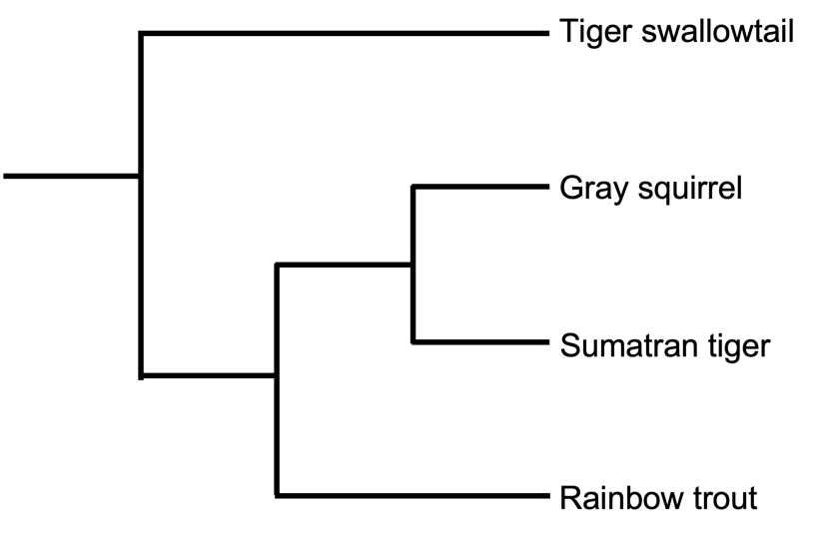
Tree redrawn with gray squirrel omitted:
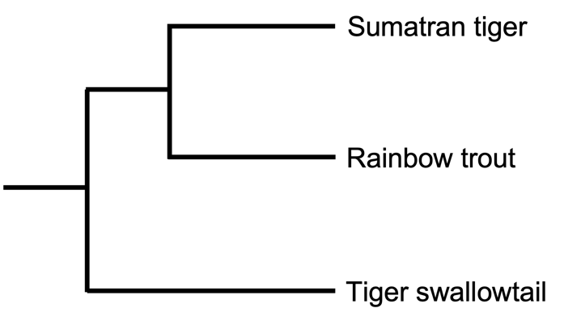
Tree redrawn with tiger swallowtail omitted (now rainbow trout is outgroup):
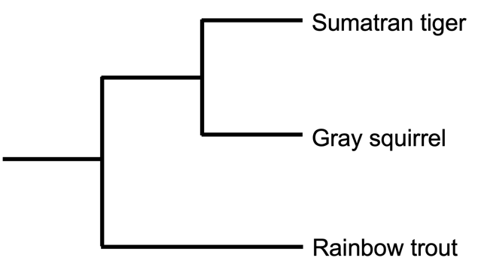

- We’re dealing with imaginary biological creatures and made-up presence/absence characters in this problem. Assume that ghost (species G) is an outgroup to apparition (species A), phantom (species P), and spook (species S). The traits present in ghost are the same as those present in the most recent common ancestor of all the other species.

Ghosts lack hair. They have no limbs, but they do have a face. They are not nocturnal creatures, and they lack malicious intent. They are not capable of vocalization.

Apparitions do have hair and a face, though they have no limbs. Unlike ghosts, they are nocturnal and are capable of vocalizing. They have no malicious intent.

Phantoms lack hair but have limbs and a face. They are active at night, and unlike ghosts and apparitions, they are malicious. They cannot vocalize.

Spooks are hairless, but they do have limbs and a face. Like phantoms, they have malicious intent, but they can vocalize, and they are not nocturnal.

Based on this information, address the following:
- Organize this information in a character matrix.
- Keeping ghost as outgroup, draw out all possible fully resolved phylogenies.
- Which phylogeny is the most parsimonious based solely on nocturnal behavior?
- Which phylogeny is the most parsimonious overall?

Character matrix (presence/absence traits: 0 = absent, 1 = present):
Species | Hair (H) | Limbs (L) | Face (F) | Nocturnal behavior (N) | Malicious intent (M) | Vocalization (V)
Ghost | 0 | 0 | 1 | 0 | 0 | 0
Apparition | 1 | 0 | 1 | 1 | 0 | 1
Phantom | 0 | 1 | 1 | 1 | 1 | 0
Spook | 0 | 1 | 1 | 0 | 1 | 1

Here are all three possible trees, keeping ghost as outgroup:
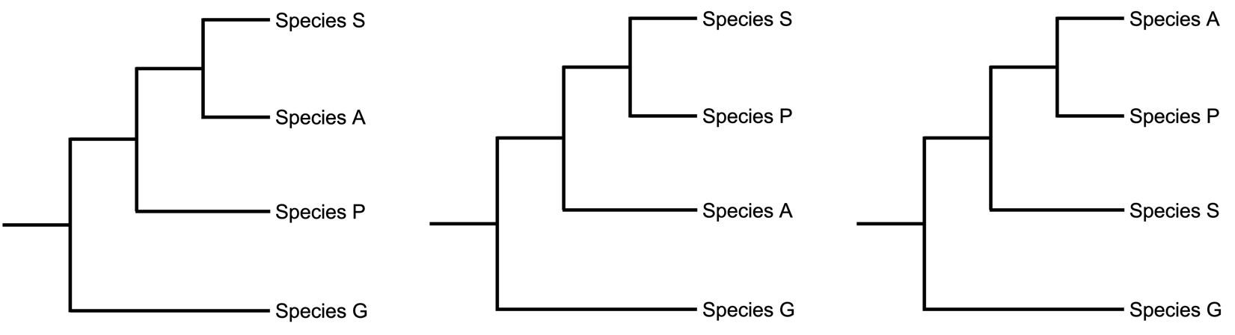

Considering only nocturnal behavior, the third tree is the most parsimonious, as it places the two species with nocturnal behavior as closest relatives.

Considering all six characters, the second tree is the most parsimonious. It requires seven total character state changes, while the first and third trees require eight. Below, character state changes are mapped onto all three trees such that only gains of traits are considered:

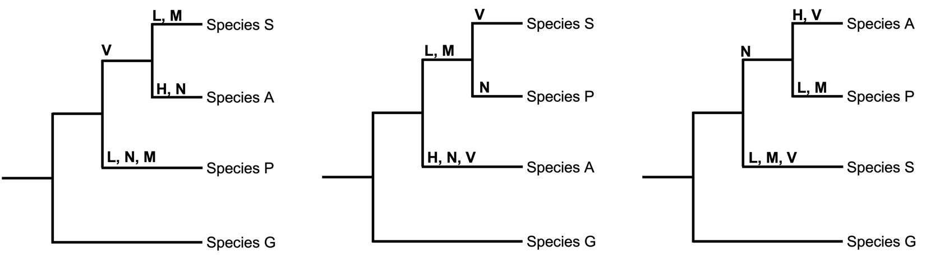

Note that because all species have a face, no character state changes are mapped onto the trees. Also note that a trait only present in one species (hair, or H) does not help us distinguish among the three possible trees, as it can always be mapped once on the terminal branch leading to the species in which it is found.

It is possible to consider gains and losses as two ways in which character state changes can occur. For the sake of simplicity, we will consider them as equally likely types of character state changes. Below, the three phylogenies are redrawn with gains and losses mapped; although some of the state changes for each character are shown on different branches from the last set of trees, the number of state changes for each character remains the same.

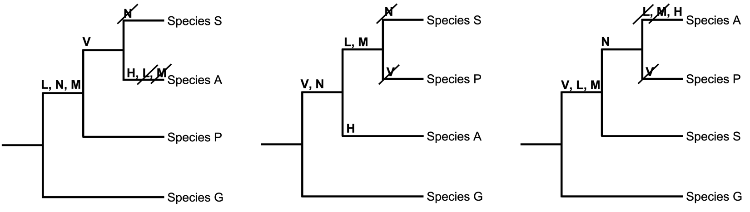

Answers are not provided for the remainder of the worksheet as each team will find a unique set of organisms, and each class will end up with a unique final tree. However, applying the principles from these introductory exercises should be sufficient to correctly complete the remaining activities. When combining trees, consider the tree pruning completed in problem 1 (when individual taxa were removed from a starting phylogeny), and reverse the process.

Photographic scavenger hunt (35% of total grade)

You have been assigned a taxonomic group. On the next page, paste photos of seven different species from your assigned taxonomic group, and use iNaturalist to provide a classification and common name for each. (Try to identify at least to family level).

Species 1 - Photo, classification, common name:

Species 2 - Photo, classification, common name:

Species 3 - Photo, classification, common name:

Species 4 - Photo, classification, common name:

Species 5 - Photo, classification, common name:

Species 6 - Photo, classification, common name:

Species 7 - Photo, classification, common name:

Phylogeny-building (50% of total grade)

- Look over your seven photos of seven species belonging to your assigned taxonomic group. Write down one or more morphological characters that you could use to build a phylogenetic tree, and draw your tree accordingly. Map relevant character state changes onto appropriate branches. (If your tree is not fully resolved, that is okay at this point.)

- Now, find one or more published phylogenies online that show evolutionary relationships among your species based on molecular data. Cite them below, and sketch a tree of just your seven species based on the published work. Is it different from the tree you drew based on a morphological character?

- Join forces with another team in the class that has been assigned a different taxonomic group. Together, combine all of your 14 species into one tree that is supported by molecular data. Sketch the tree below.

- Look at the tree you just drew that includes 14 species. Are any of your seven species more closely related to a member of a different taxonomic group than they are to members of their own? Why or why not?

- Finally, sketch a simple phylogeny that represents all of the taxonomic groups assigned to different teams in the class. Map at least two characters onto this tree. Do not worry about individual species in each group; just include each taxonomic group as a whole.

Take-aways and further reading

Through this activity, you have done the following:

- In the introductory portion, you have gained experience analyzing (questions 1 and 2) and building (question 3) simple phylogenetic trees.
- In the photographic scavenger hunt portion, you have explored and documented local biological diversity. You have also contributed to iNaturalist, a database utilized by both amateur naturalists and professional researchers.
- In the final phylogeny-building portion, you have applied phylogenetics to the species with whom you share your geographic area. You have also
  - Used an easily observable character to reconstruct a hypothetical phylogeny
  - Analyzed phylogenies in published scientific literature and interpreted them with respect to your observed species
  - Practiced adding taxa to a phylogeny by combining your tree with another team’s, and by creating one tree to represent all assigned taxonomic groups

For more information, supplemental instruction, and an overview of why phylogenies matter, check out the following resources:
- A tutorial in phylogenetics from the European Molecular Biology Laboratory, with a page dedicated to the importance of phylogenies:
Phylogenetics - an introduction. EMBL-EBI homepage. https://www.ebi.ac.uk/training/online/courses/introduction-to-phylogenetics/
- An in-depth explanation of phylogenies, and a correction of common misinterpretations:
The history of life: Looking at the patterns - understanding evolution. Understanding Evolution - Your one-stop source for information on evolution. (2022, February 10). https://evolution.berkeley.edu/evolution-101/the-history-of-life-looking-at-the-patterns/
- A brief history of the use of phylogenetics to solve crimes:
No hiding among the trees: Forensic phylogenetics. Small Things Considered. (n.d.). https://schaechter.asmblog.org/schaechter/2018/06/no-hiding-among-the-trees-forensic-phylogenetics.html

